SIMATS ENGINEERING
ASSESSMENT TOOL 2

COURSE NAME: Database Management Systems
COURSE CODE: CSA05

COURSE OUTCOME COVERED

CO1: Analyse DBMS architecture, different data models, schema types, and design ER/EER diagrams, relational schemas for case-based scenarios by identifying entities and relationships. (BL1, BL2)

Activity Tool : Concept Mapping (Medium)
Assessment Tool Weightage: 20%

QUESTIONS
Q.N o | Question | Bloom's Level
1 | Construct a concept map linking the following terms: DBMS, Schema, Instance, Data Model, ER Diagram, Entity, Attribute, Relationship. | BL2 – Understand
2 | Create a concept map for the three-level ANSI/SPARC architecture showing data independence at each level. | BL2 – Understand
3 | Map the relationship between file-based systems and database systems, highlighting the problems solved by DBMS. | BL2 – Understand
4 | Design a concept map for ER diagram components: entity, weak entity, attribute types, relationship types, and participation constraints. | BL2 – Understand
5 | Construct a concept map comparing Hierarchical, Network, and Relational data models with their key properties. | BL2 – Understand
6 | Develop a concept map for the EER model showing how it extends the basic ER model with generalization, specialization, and aggregation. | BL2 – Understand
7 | Create a visual concept map for the DBMS software architecture, illustrating the flow from user request to data retrieval. | BL2 – Understand
8 | Map the data models discussed in CO1 to real-world applications and explain the suitability of each model. | BL2 – Understand
9 | Construct a concept map for schemas and instances, showing how they relate to physical and logical data independence. | BL2 – Understand
10 | Design a concept map for the roles and responsibilities in a DBMS environment: DBA, End User, Application Developer. | BL1 – Remember

Code of Conduct:

Criteria | Weightage | Level 4 (Exemplary) | Level 3 (Proficient) | Level 2  (Developing  ) | Level 1 (Beginning)
Concept  Identification | 25% | Identifies all key concepts from literature  accurately and  comprehensivel  y | Identifies most key concepts  with minor omissions | Identifies limited  concepts; some are  irrelevant or missing | Fails to identify  essential concepts
Linkages | 25% | Establishes clear,  meaningful, and accurate  relationships between concepts | Shows correct  relationships  with minor gaps | Relationship  s are weak,  unclear, or partially incorrect | No meaningful relationships established
Organization | 20% | Concepts are well-structured hierarchically  with logical flow and grouping | Mostly organized  with minor  structural issues | Some  organization but lacks clear hierarchy | No logical organization or structure
I ________AKCHAYADEVI.G(192524501)____________ (Name / Reg No) certify that this submission is my original work and that I have adhered to the guidelines specified for this assessment. I understand that any violation of academic integrity rules will result in disciplinary action.
AKCHAYADEVI.G
Signature of the student:

RUBRICS FOR CALCULATION:

Integration of Literature | 20% | Integrates multiple studies effectively to show  connections and comparisons | Shows some integration of literature | Limited integration; mostly  isolated concepts | No integration of literature evidence
Clarity | 10% | Concept map is clear, neat, visually  structured, and easy to interpret | Generally clear with minor  readability issues | Clarity is reduced;  difficult to  interpret in parts | Poorly presented and hard to understand

Question 1
Construct a Concept Map Linking the Following Terms:
DBMS, Schema, Instance, Data Model, ER Diagram, Entity, Attribute, Relationship

Answer
Introduction
A Database Management System (DBMS) is software that helps users create, store, organize, retrieve, and manage data efficiently. Before creating a database, a Data Model is used to define how the data should be structured. One of the most common conceptual data models is the Entity-Relationship (ER) Model, which is represented using an ER Diagram. The ER Diagram consists of Entities, Attributes, and Relationships, which together form the Database Schema. The DBMS uses this schema to store and manage the Database Instance, which contains the actual data at a specific point in time.

1. Data Model
- A Data Model is a collection of concepts used to describe the structure of data.
- It defines how data is organized, stored, and related.
- Example: ER Model, Relational Model.

2. ER Diagram
- An ER Diagram (Entity-Relationship Diagram) is a graphical representation of database design.
- It helps in planning the database before implementation.
- It is created based on the Data Model.

3. Entity
- An Entity is a real-world object or thing that can be identified uniquely.
- Examples:
  - Student
  - Employee
  - Product
  - Customer

4. Attribute
- An Attribute describes the characteristics or properties of an entity.
- Example:
  - Student ID
  - Name
  - Age
  - Department

5. Relationship
- A Relationship shows the association between two or more entities.
- Examples:
  - Student enrolls in Course
  - Customer places Order
  - Employee works in Department

6. Schema
- A Schema is the logical blueprint or structure of the database.
- It defines tables, columns, constraints, and relationships.
- The schema changes very rarely.

7. DBMS
- DBMS stands for Database Management System.
- It manages the database by performing operations such as:
  - Data Storage
  - Data Retrieval
  - Data Manipulation
  - Data Security
  - Backup and Recovery
Examples:
- MySQL
- Oracle
- SQL Server
- PostgreSQL

8. Instance
- An Instance is the actual data stored in the database at a particular point in time.
- It changes whenever records are inserted, updated, or deleted.

CONCEPT MAP

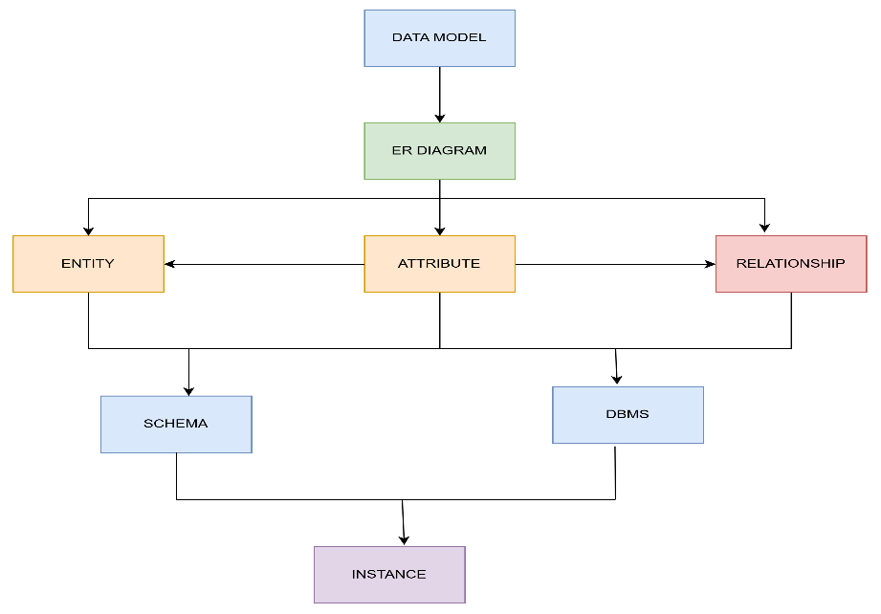

ER DIAGRAM

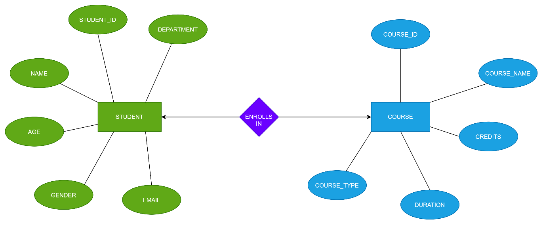

Example
Student Database
Entity: Student
Attributes:
- Student_ID
- Name
- Age
- Department
Relationship:
- Student Enrolls In Course
This information is represented using an ER Diagram, which is converted into a Schema. The DBMS uses the schema to store and manage the Instance (actual student records).

Conclusion
The concept map shows the complete process of database design. A Data Model provides the foundation for creating an ER Diagram, which consists of Entities, Attributes, and Relationships. These elements form the Database Schema, which is managed by the DBMS. The DBMS stores the Instance, representing the actual data in the database at a specific time.

2.
a Concept Map for the Three-Level ANSI/SPARC Architecture Showing Data Independence at Each Level

Explanation
The ANSI/ Create SPARC Three-Level Architecture is a database architecture proposed to separate user applications from the physical database. It organizes the database into three levels: External Level, Conceptual Level, and Internal Level. This separation provides data independence, making the database easier to maintain, secure, and modify without affecting users or applications.

CONCEPT MAP

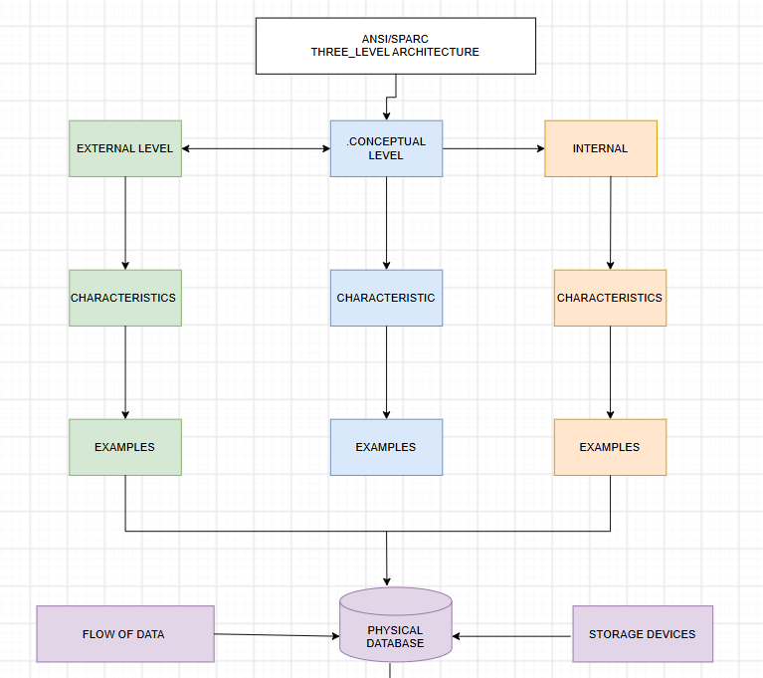

1. External Level (View Level)
The External Level is the highest level of the architecture. It represents how different users view the database. Each user or department can have a different view depending on their requirements.
Characteristics
- Provides multiple user views.
- Displays only the required data.
- Hides unnecessary information.
- Improves data security.
Examples
- Student View
- Faculty View
- Accounts View
- Library View

2. Conceptual Level (Logical Level)
The Conceptual Level describes the complete logical structure of the database. It defines all entities, attributes, relationships, constraints, and rules without considering how the data is physically stored.
Characteristics
- Represents the entire database.
- Defines entities, relationships, and attributes.
- Independent of physical storage.
- Maintains data consistency.
Examples
- ER Diagram
- Database Schema
- Tables
- Primary Keys and Foreign Keys

3. Internal Level (Physical Level)
The Internal Level is the lowest level of the architecture. It describes how data is physically stored in storage devices such as hard disks or SSDs.
Characteristics
- Defines physical storage methods.
- Manages indexes and file organization.
- Optimizes storage and retrieval speed.
- Handles memory allocation.
Examples
- Heap Files
- B+ Tree Indexes
- Hash Files
- Disk Blocks

Data Independence
One of the major advantages of the ANSI/SPARC architecture is Data Independence, which means changes at one level do not affect the other levels.
1. Logical Data Independence
- Changes made at the Conceptual Level do not affect the External Level.
- User views remain unchanged even if the logical database structure is modified.
Example
Adding a new column (Email) to the Student table does not affect the existing student or faculty views.

2. Physical Data Independence
- Changes made at the Internal Level do not affect the Conceptual Level.
- The logical structure remains unchanged even if the storage method changes.
Example
Changing data storage from Hard Disk to SSD or creating a new index does not affect the database schema or application programs.

Advantages of ANSI/SPARC Three-Level Architecture
- Provides Logical Data Independence.
- Provides Physical Data Independence.
- Supports multiple user views.
- Improves data security.
- Simplifies database maintenance.
- Makes database modification easier.
- Reduces application dependency.
- Enhances data sharing and consistency.

Conclusion
The ANSI/SPARC Three-Level Architecture divides the database into External, Conceptual, and Internal levels. This separation ensures logical and physical data independence, allowing changes in one level without affecting the others. As a result, databases become more secure, flexible, efficient, and easier to maintain. This architecture is widely used in modern Database Management Systems (DBMS).

3. Question 3
Map the Relationship Between File-Based Systems and Database Systems, Highlighting the Problems Solved by DBMS

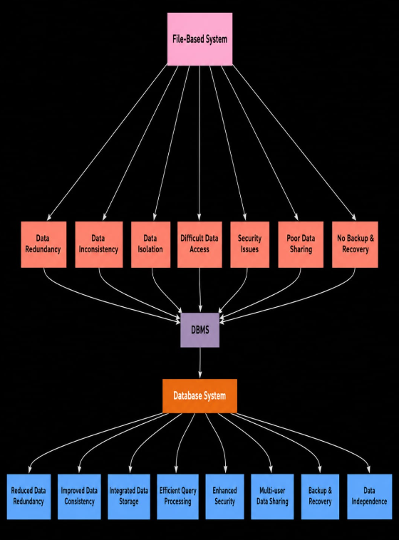

Explanation
A File-Based System is the traditional method of storing data in separate files. Each application maintains its own files independently, resulting in duplicate data, poor security, and difficulty in managing information. A Database Management System (DBMS) is an advanced software system that stores data in an organized database and provides efficient data management, security, and sharing.
The concept map compares the characteristics of the File System and DBMS, showing how DBMS overcomes the limitations of file-based systems.

1. File-Based Syste
A File-Based System stores data in separate files created by different application programs. Each application manages its own data independently.
Characteristics
- Data is stored in separate files.
- High data redundancy.
- Data inconsistency may occur.
- Limited data sharing.
- Low security.
- No backup and recovery.
- Difficult to retrieve data.
- No concurrency control.
- Data depends on application programs.
Examples
- Text Files (.txt)
- Excel Files (.xlsx)
- CSV Files

Problems in File-Based System
1. Data Redundancy
The same data is stored in multiple files, resulting in unnecessary duplication.
Example:
A student's details may be stored separately in the library, examination, and accounts files.

2. Data Inconsistency
When duplicate data is updated in one file but not in others, inconsistent information is produced.
Example:
A student's phone number is updated in the examination file but remains unchanged in the library file.

3. Data Isolation
Data is stored in different files and formats, making it difficult to combine information.

4. Poor Security
There are limited security mechanisms to protect confidential information.

5. No Backup and Recovery
If a file is deleted or corrupted, recovering the data is difficult.

6. No Data Sharing
Different users cannot easily share data because each application stores its own files.

7. No Concurrency Control
When multiple users access the same file simultaneously, conflicts may occur.

2. Database Management System (DBMS)
A DBMS is software used to create, store, organize, retrieve, and manage data efficiently in a centralized database.
Characteristics
- Data stored in related tables.
- Low data redundancy.
- High data consistency.
- Data sharing among users.
- Strong security.
- Backup and recovery support.
- Fast data retrieval.
- Concurrency control.
- Logical and physical data independence.
Examples
- MySQL
- Oracle
- SQL Server
- PostgreSQL

How DBMS Solves File System Problems
Problem in File System | Solution Provided by DBMS
High Data Redundancy | Reduces duplicate data through centralized storage
Data Inconsistency | Maintains consistent data across the database
Data Isolation | Integrates all data into a single database
Poor Security | Provides authentication, authorization, and access control
No Backup | Supports automatic backup and recovery
Difficult Data Access | Enables fast retrieval using SQL queries
No Concurrency Control | Allows multiple users to access data safely
Program-Data Dependence | Provides logical and physical data independence

Advantages of DBMS Over File System
- Reduces data redundancy.
- Eliminates data inconsistency.
- Improves data sharing.
- Provides high-level security.
- Supports backup and recovery.
- Allows multiple users to work simultaneously.
- Ensures data integrity.
- Offers logical and physical data independence.
- Improves overall database performance.
- Simplifies database maintenance.

Conclusion
A File-Based System is suitable only for small applications but suffers from problems such as data redundancy, inconsistency, poor security, and limited data sharing. A Database Management System (DBMS) overcomes these limitations by providing centralized data storage, security, backup, concurrency control, and data independence. Therefore, DBMS is the preferred solution for managing large and complex databases efficiently.

4. Question 4
Design a Concept Map for ER Diagram Components: Entity, Weak Entity, Attribute Types, Relationship Types, and Participation Constraints

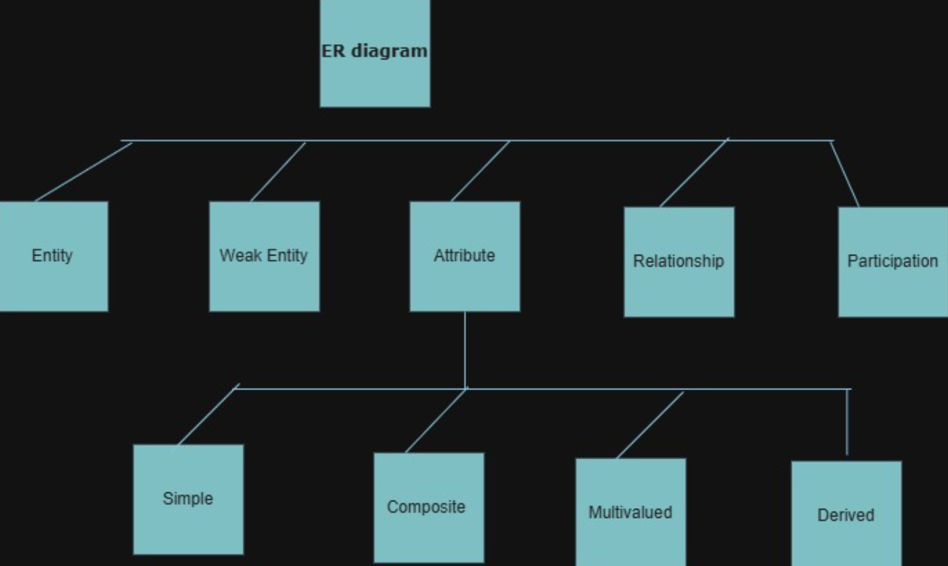

Explanation
An Entity-Relationship (ER) Diagram is a graphical representation of a database used during database design. It shows how different entities are related to each other and identifies the attributes associated with each entity. The main components of an ER diagram are Entities, Weak Entities, Attributes, Relationships, and Participation Constraints.

1. Entity
An Entity is any real-world object, person, place, or thing that can be uniquely identified and about which data is stored in a database.
Characteristics
- Represents real-world objects.
- Has a unique identity.
- Contains attributes.
Examples
- Student
- Employee
- Customer
- Product
Notation: Rectangle

2. Weak Entity
A Weak Entity is an entity that cannot be uniquely identified by its own attributes. It depends on another (strong) entity for its existence.
Characteristics
- Has no primary key of its own.
- Depends on a strong entity.
- Uses a partial key.
Example
- Employee → Dependent
- A dependent cannot exist without an employee.
Notation: Double Rectangle

3. Attribute Types
An Attribute describes the characteristics or properties of an entity.
Types of Attributes
a) Simple Attribute
Cannot be divided further.
Example: Age

b) Composite Attribute
Can be divided into smaller parts.
Example: Address
- Street
- City
- State
- PIN Code

c) Single-Valued Attribute
Stores only one value.
Example: Roll Number

d) Multi-Valued Attribute
Stores more than one value.
Example: Phone Numbers

e) Derived Attribute
Calculated from another attribute.
Example: Age (calculated from Date of Birth)

f) Key Attribute
Uniquely identifies an entity.
Example: Student_ID
Notation: Ellipse (Key Attribute is underlined)

4. Relationship Types
A Relationship shows the association between two or more entities.
Types of Relationships
One-to-One (1:1)
One entity is related to only one entity.
Example: Person → Passport

One-to-Many (1:M)
One entity is related to many entities.
Example: Department → Employees

Many-to-One (M:1)
Many entities are related to one entity.
Example: Employees → Department

Many-to-Many (M:N)
Many entities are related to many entities.
Example: Students → Courses

Notation: Diamond

5. Participation Constraints
Participation constraints specify whether all entities must participate in a relationship.
a) Total Participation
Every entity must participate in the relationship.
Example:
Every employee must belong to a department.
Notation: Double Line

b) Partial Participation
Participation in the relationship is optional.
Example:
A customer may or may not place an order.
Notation: Single Line

Advantages of ER Diagrams
- Simplifies database design.
- Clearly represents entities and their relationships.
- Reduces data redundancy.
- Improves communication between designers and users.
- Provides a blueprint before database implementation.
- Helps convert the design into relational tables.

Conclusion
An ER Diagram is an essential database design tool that represents entities, weak entities, attributes, relationships, and participation constraints. These components help designers create a structured, accurate, and efficient database that minimizes redundancy and ensures data integrity.

5,
Question 5
Construct a Concept Map Comparing Hierarchical, Network, and Relational Data Models with Their Key Properties

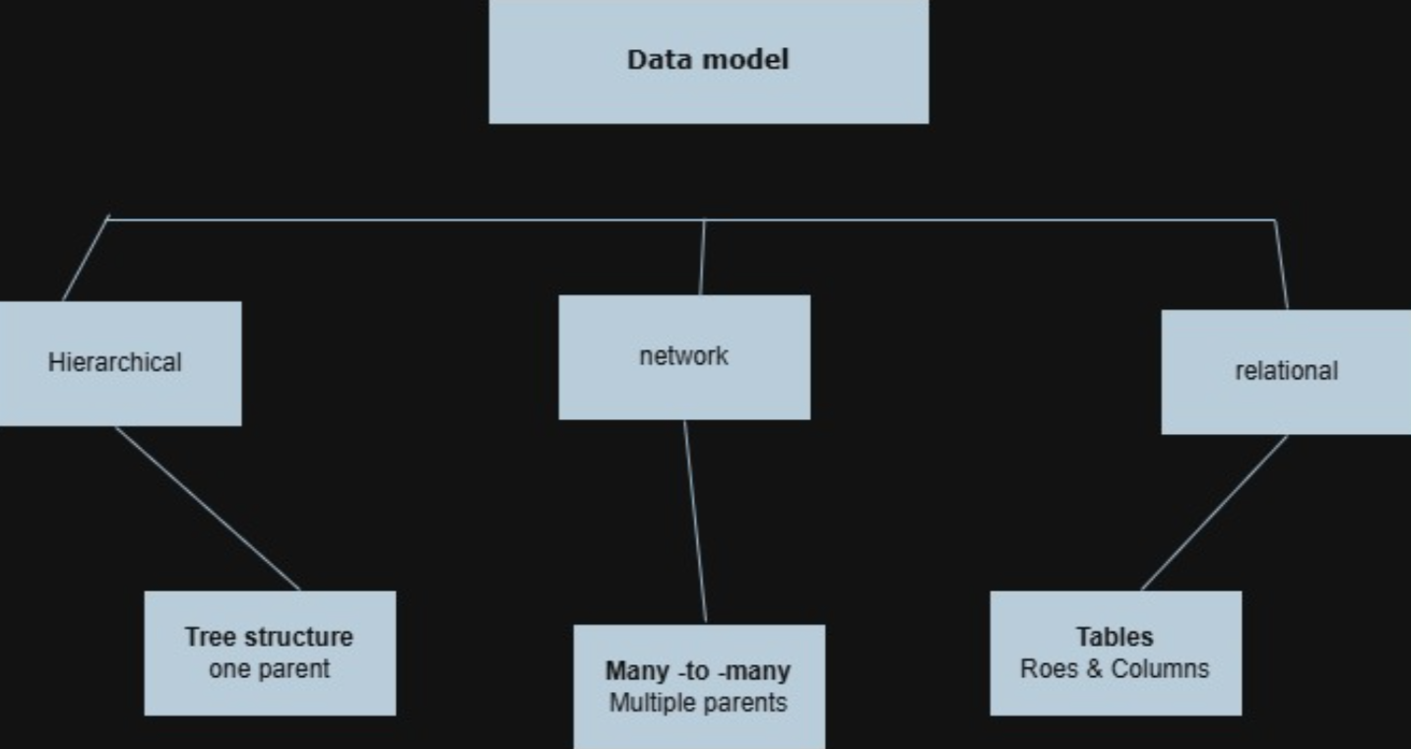

Explanation
A Data Model is a method used to organize, store, and manage data in a database. The three major data models are Hierarchical, Network, and Relational. Each model stores data differently and is suitable for different applications.

1. Hierarchical Data Model
The Hierarchical Data Model organizes data in a tree-like structure. It consists of a single parent at the top and multiple child records below it. Each child can have only one parent.
Characteristics
- Tree structure (Parent → Child).
- One-to-Many (1:M) relationship.
- Each child has only one parent.
- Fast data retrieval for hierarchical data.
- Rigid and difficult to modify.
Advantages
- Simple to understand.
- Fast access to parent-child data.
- Good performance for hierarchical applications.
Disadvantages
- Does not support many-to-many relationships.
- Difficult to reorganize the database.
- High data redundancy.
Example
- Organization Chart
- File Directory Structure
- Company Employee Hierarchy

2. Network Data Model
The Network Data Model organizes data as a graph, where one record can have multiple parent and child records. It supports many-to-many (M:N) relationships.
Characteristics
- Graph structure.
- Supports many-to-many relationships.
- Flexible data access.
- Multiple paths to reach data.
Advantages
- Reduces data redundancy.
- Supports complex relationships.
- Faster than hierarchical model for complex databases.
Disadvantages
- Complex structure.
- Difficult to design and maintain.
- Requires more programming knowledge.
Example
- Airline Reservation System
- Banking System
- University Database

3. Relational Data Model
The Relational Data Model stores data in the form of tables (relations). Each table consists of rows (records) and columns (attributes). Relationships between tables are established using Primary Keys and Foreign Keys.
Characteristics
- Data stored in tables.
- Uses rows and columns.
- Supports SQL.
- Easy to maintain.
- Most widely used model.
Advantages
- Easy to understand.
- Reduces redundancy through normalization.
- Provides high data integrity.
- Supports security and concurrency.
Disadvantages
- Slightly slower for very complex queries.
- Large databases may require optimization.
Example
- MySQL
- Oracle Database
- SQL Server
- PostgreSQL

